CLOUD CC-1

HARISH V

727721EUIT051

727721EUIT051@SKCET.AC.IN

1.CREATE AN EC2 INSTANCE IN THE US EAST-1 REGION

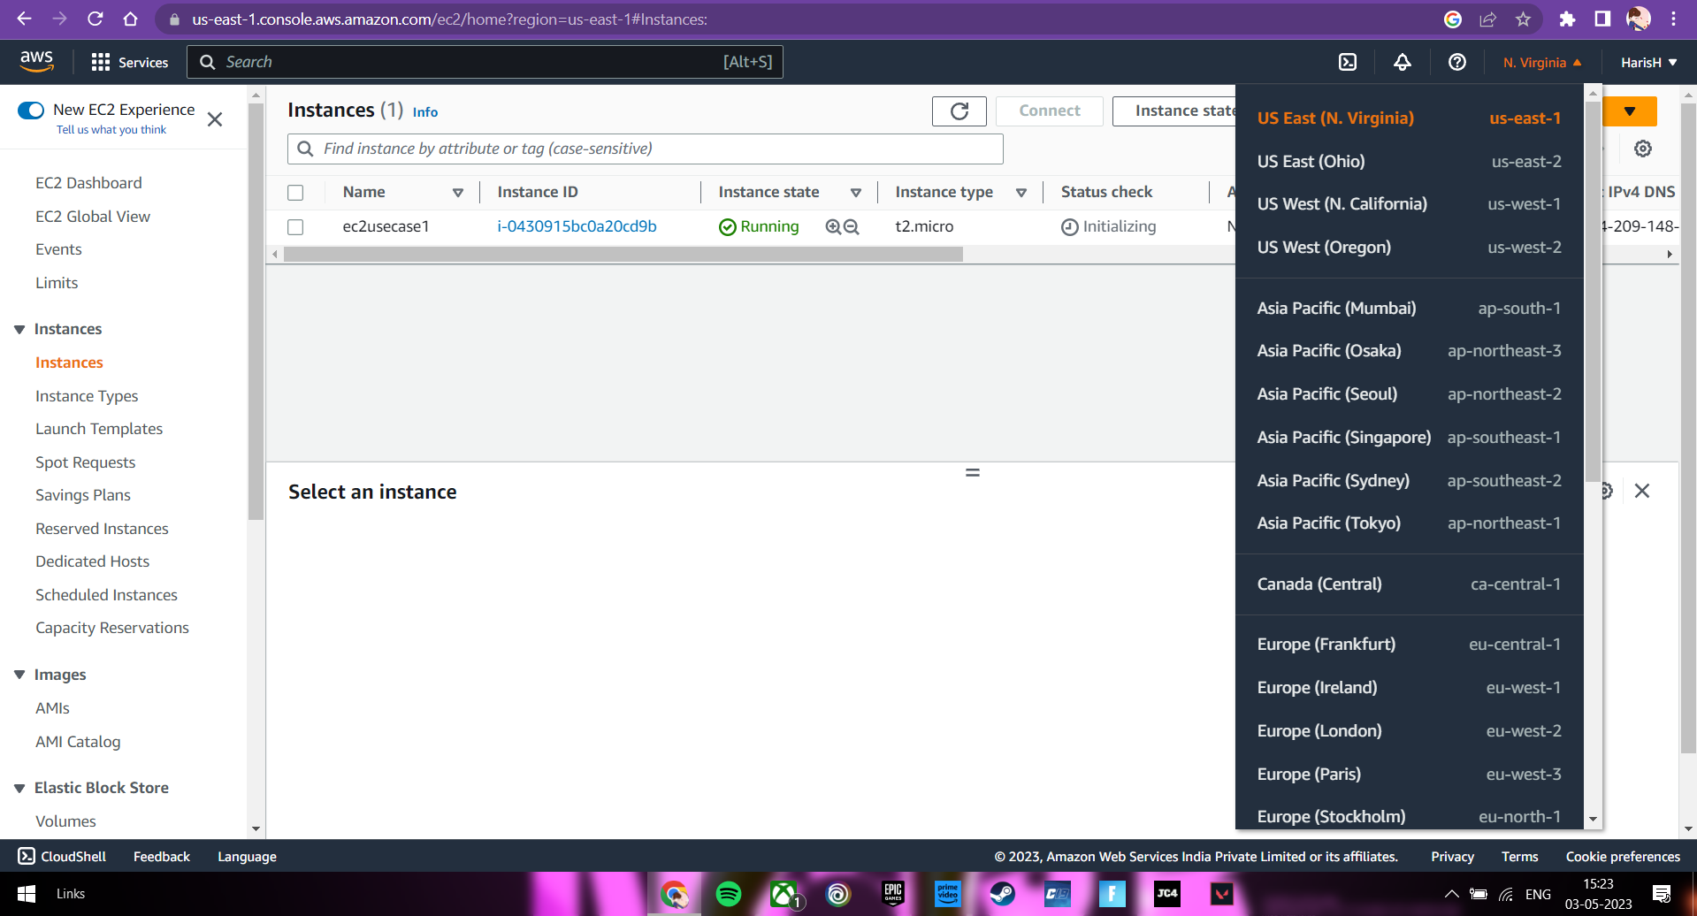

GIVE THE NAMETAG OF BOTH EC2 INSTANCE AND KEYPAIR AS “ec2usecase1”

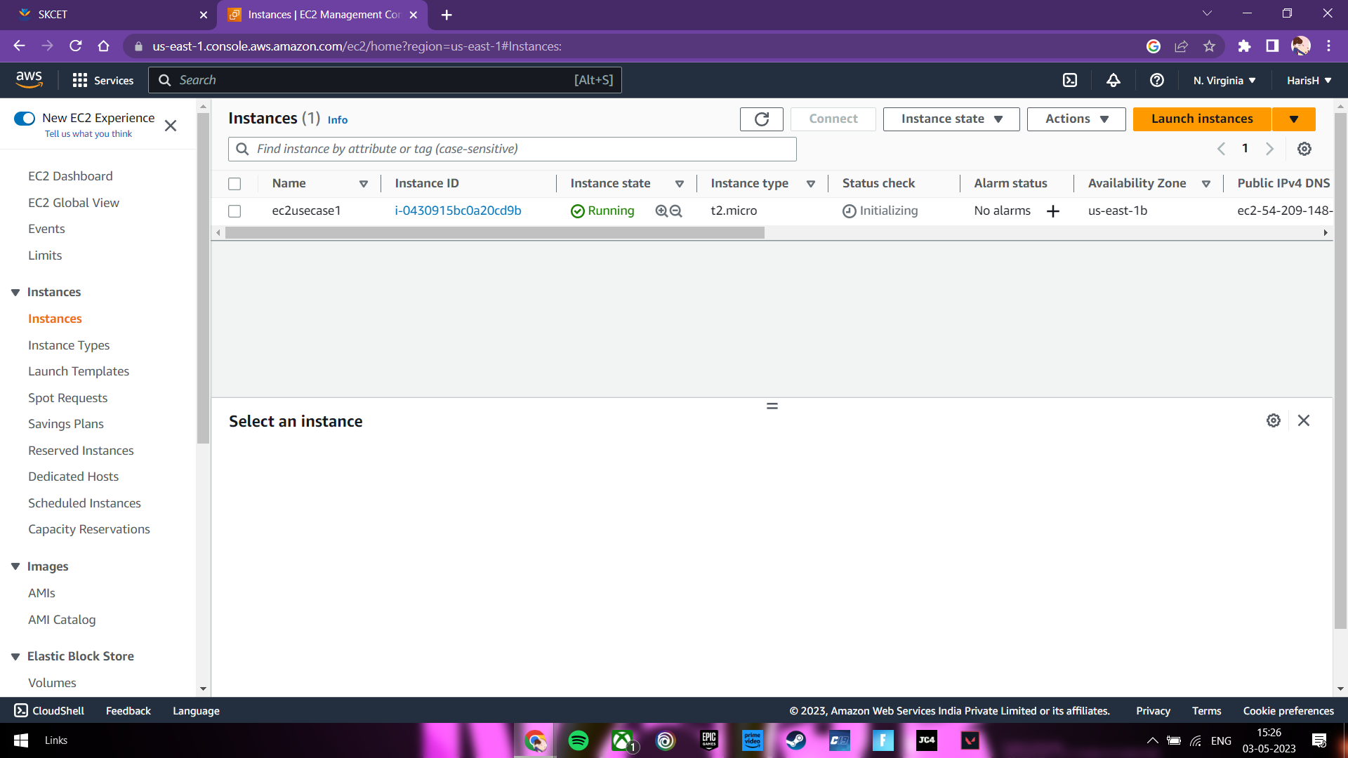

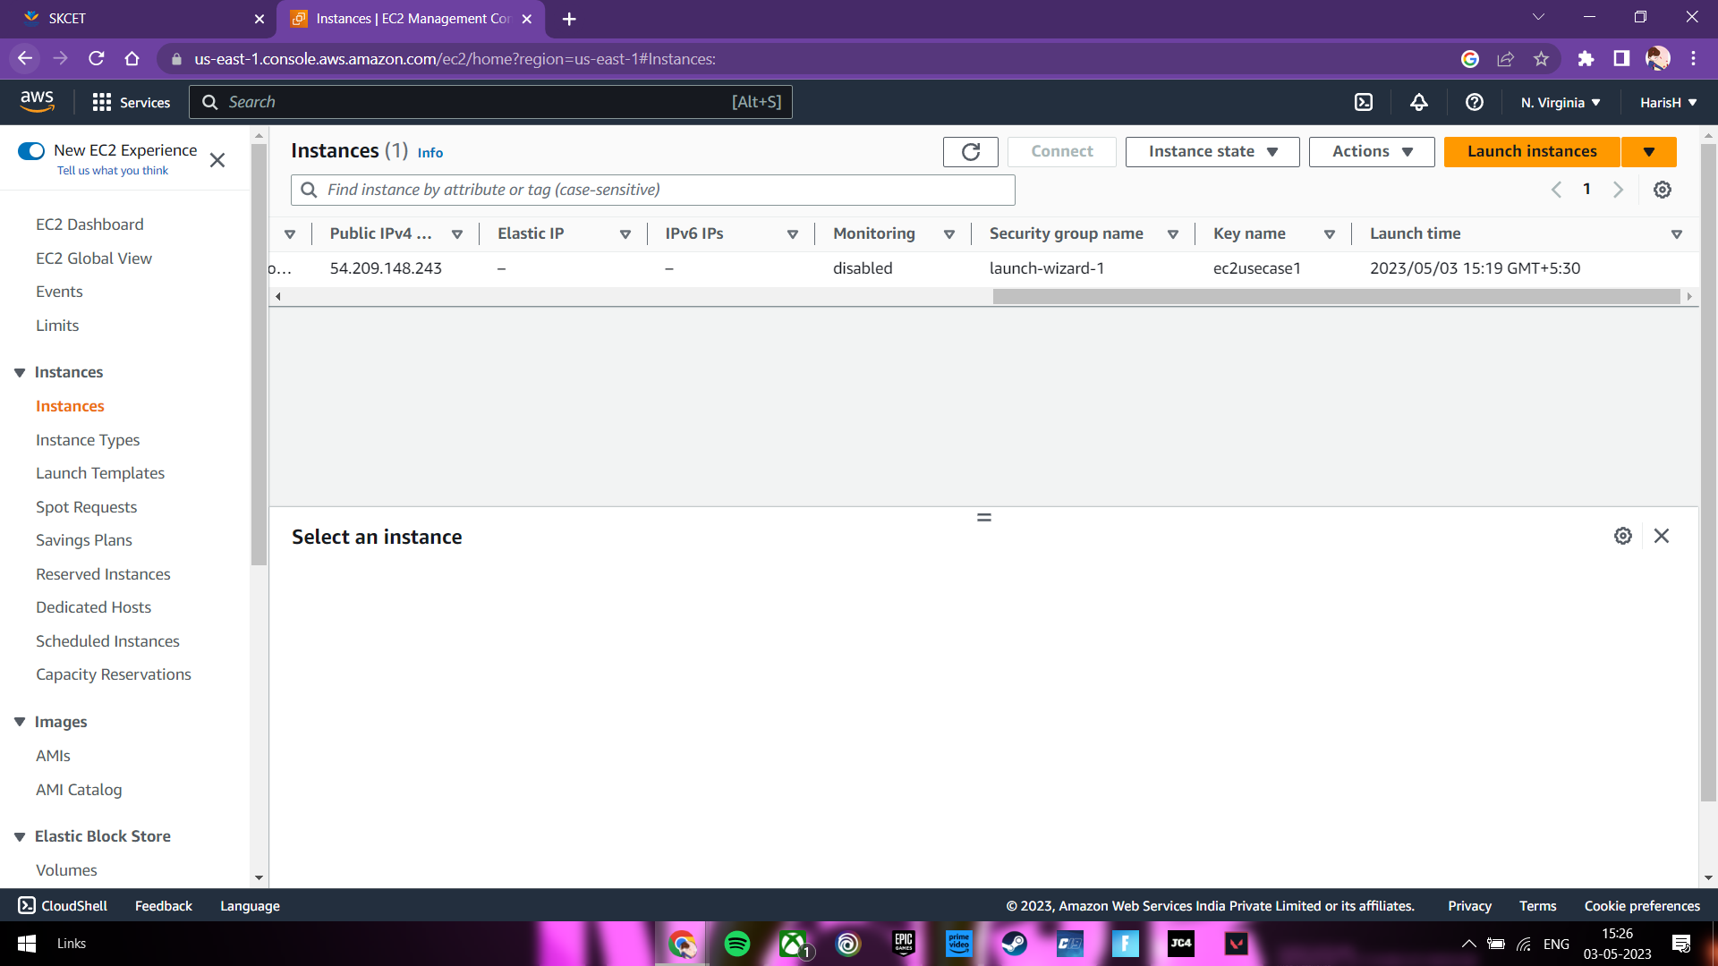

EC2 INSTANCE AMI SHOULD BE “AMAZON LINUX 2”

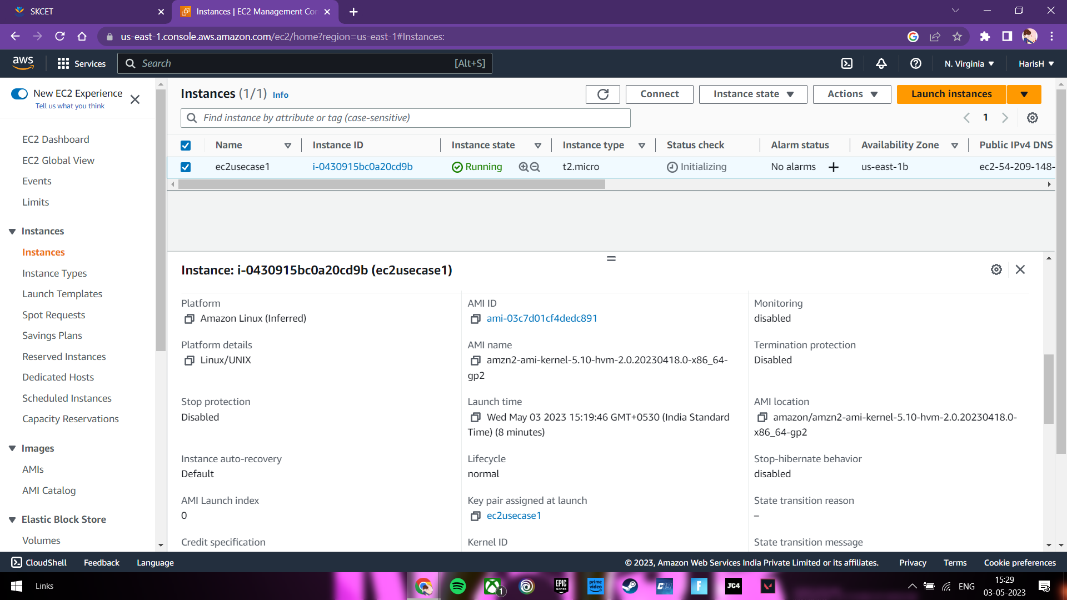

ALLOW SSH TRAFFIC AND HTTP TRAFFIC

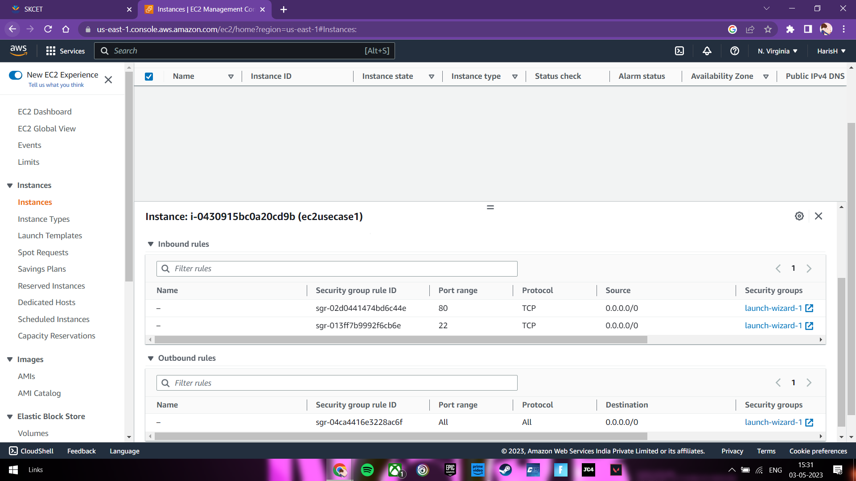

2.CREATE AN S3 BUCKET IN THE REGION OF “STOCKHOLM”

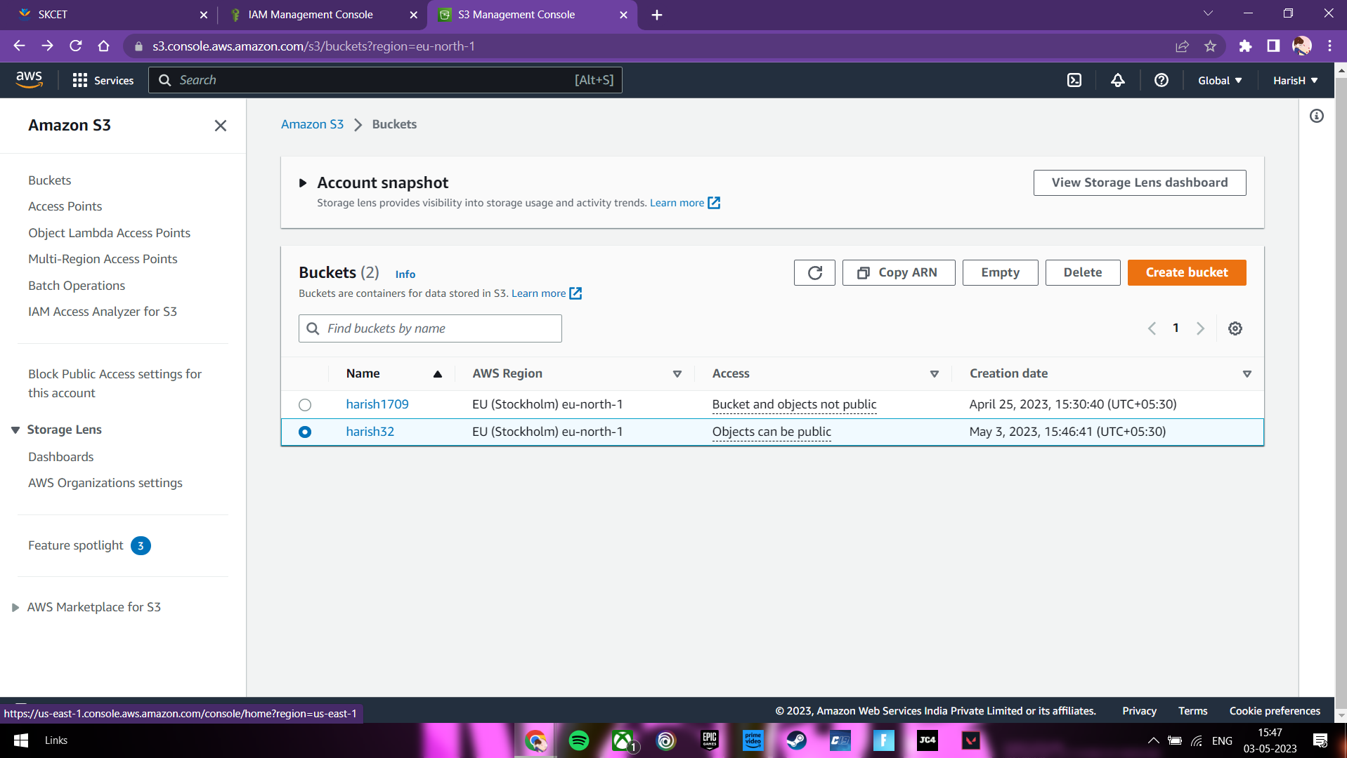

MAKE THE BUCKET TO PUBLIC ACCESSIBLE

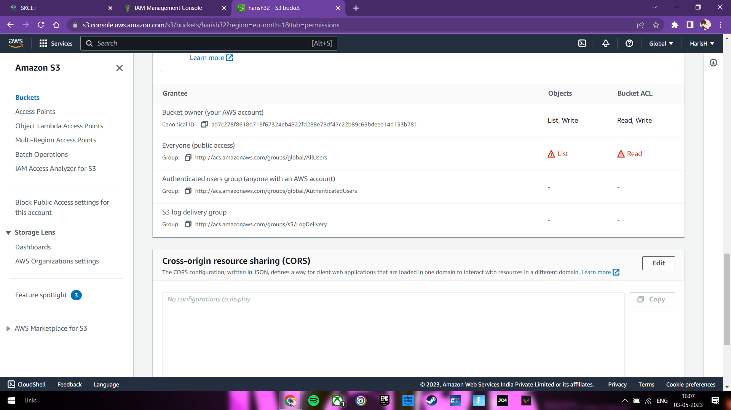

UPLOAD A TEXT FILE AS “ACCOUNT.TXT”

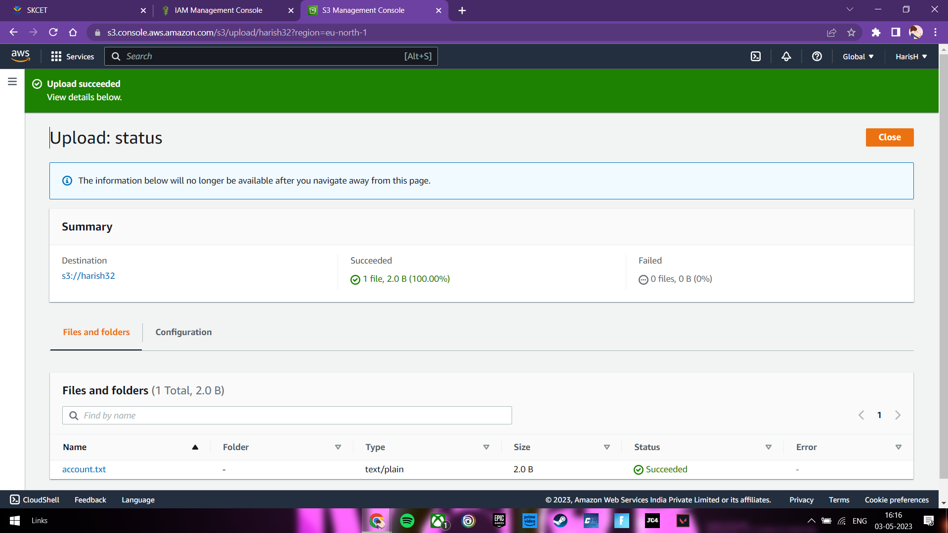

MAKE THE OBJECT ACCESSIBLE TO PUBLIC

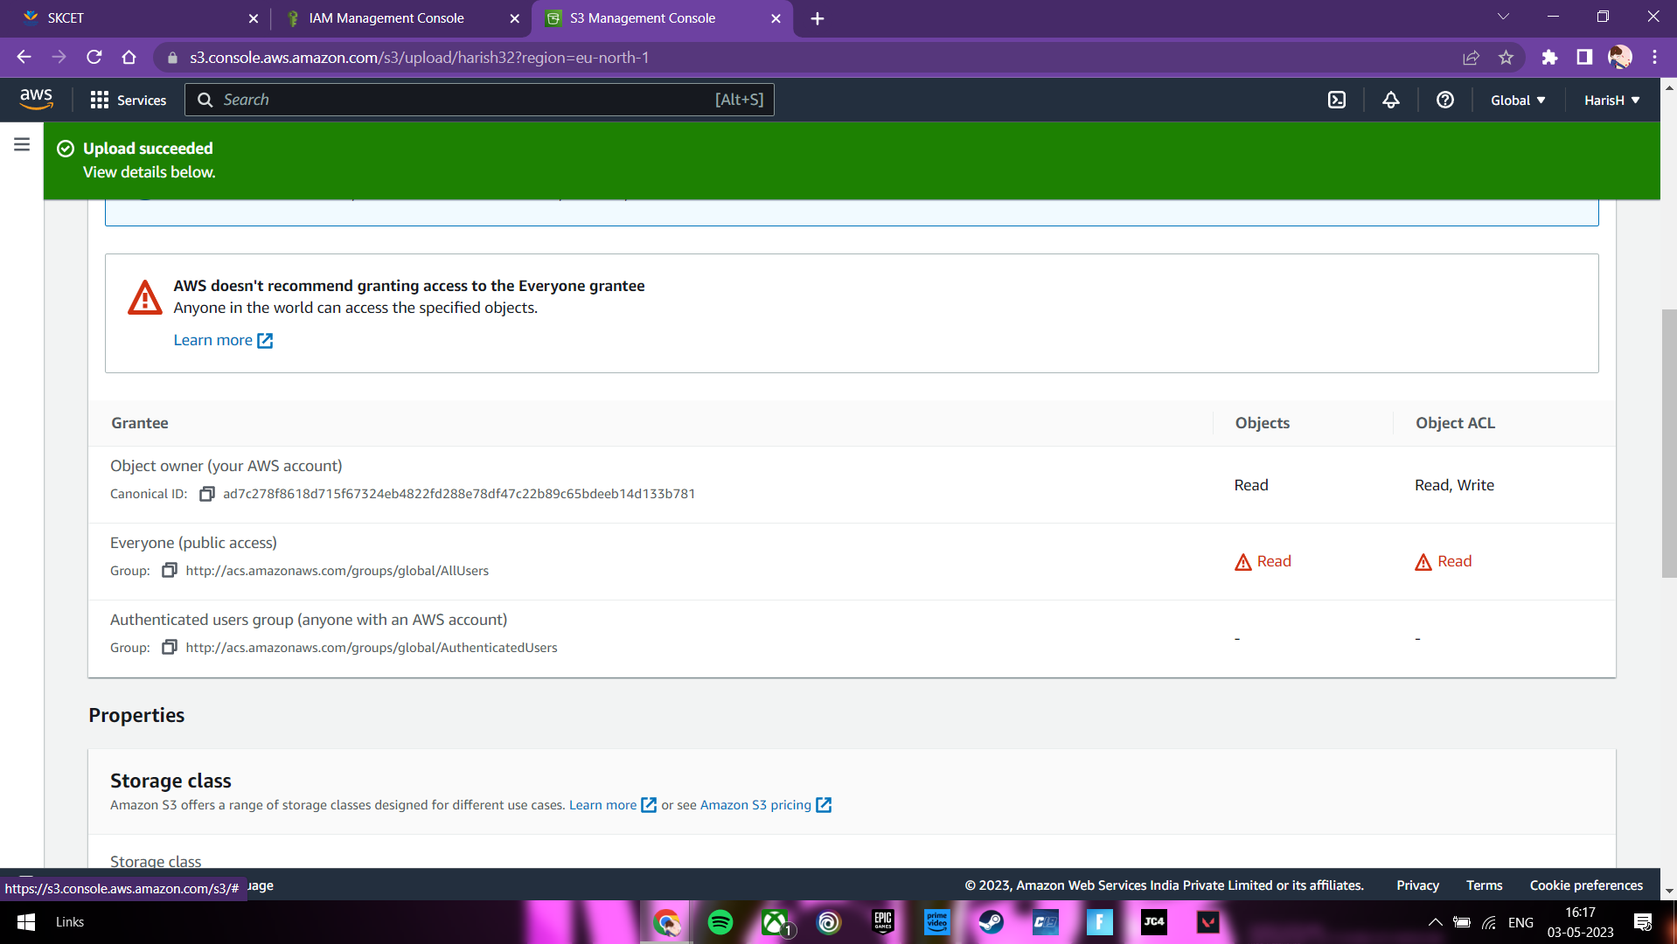

3.CREATE AN IAM GROUP BE “Network-L1-Team”

